Android App Testing Screenshots

Row No.: 8

|  |  |  |  |  |
| --- | --- | --- | --- | --- |
| **Description** | **Test Steps** | **Expected Output** | **Test Status** | **Comments** |
| Password Reset Flow | 1. Open Login Page 2. Click Forgot Password 3. Enter Registered Email 4. Receive Reset Link 5. Click Reset Link 6. Enter New Password 7. Confirm New Password | Successfully Reset Password and Able to Login | **Fail** | Emai is being sent as it gives the message 'Something went wrong. Please ty again later' |

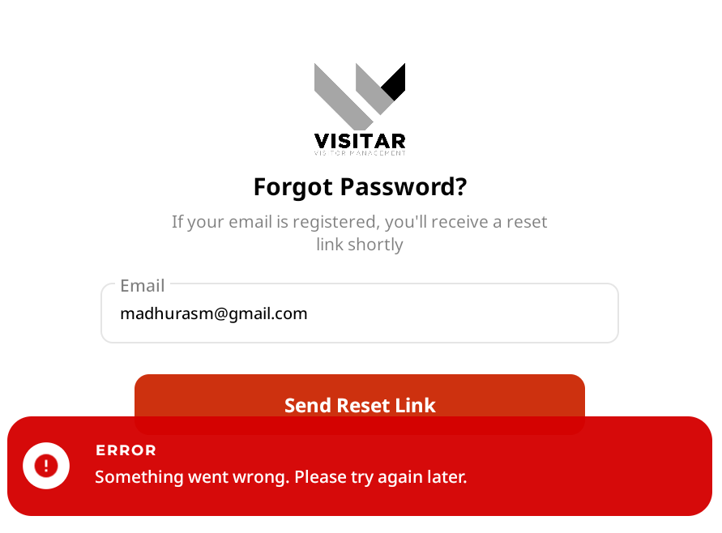

Row No. 9

|  |  |  |  |  |
| --- | --- | --- | --- | --- |
| **Description** | **Test Steps** | **Expected Output** | **Test Status** | **Comments** |
| Device Compatibility Check | 1. Test Login on Different Mobile Devices 2. Verify Responsive Design 3. Check All Functionalities | Consistent UI and Functionality Across Devices |  |  |